**Date:26/03/2024 Prepared By: Shrikanth C R**

**BUILD DOCKER IMAGE & PUSH TO DOCKER HUB USING JENKINS PIPELINE:**

**Prequisites for Jenkins Master:**

#!/bin/bash

sudo su -

yum update -y

yum install git -y

yum install maven -y

yum install java-17 -y

yum install docker -y

systemctl start docker

systemctl enable docker

docker run -d -p 8080:8080 -p 50000:50000 jenkins/jenkins:lts

**Prequisites for Jenkins Slave:**

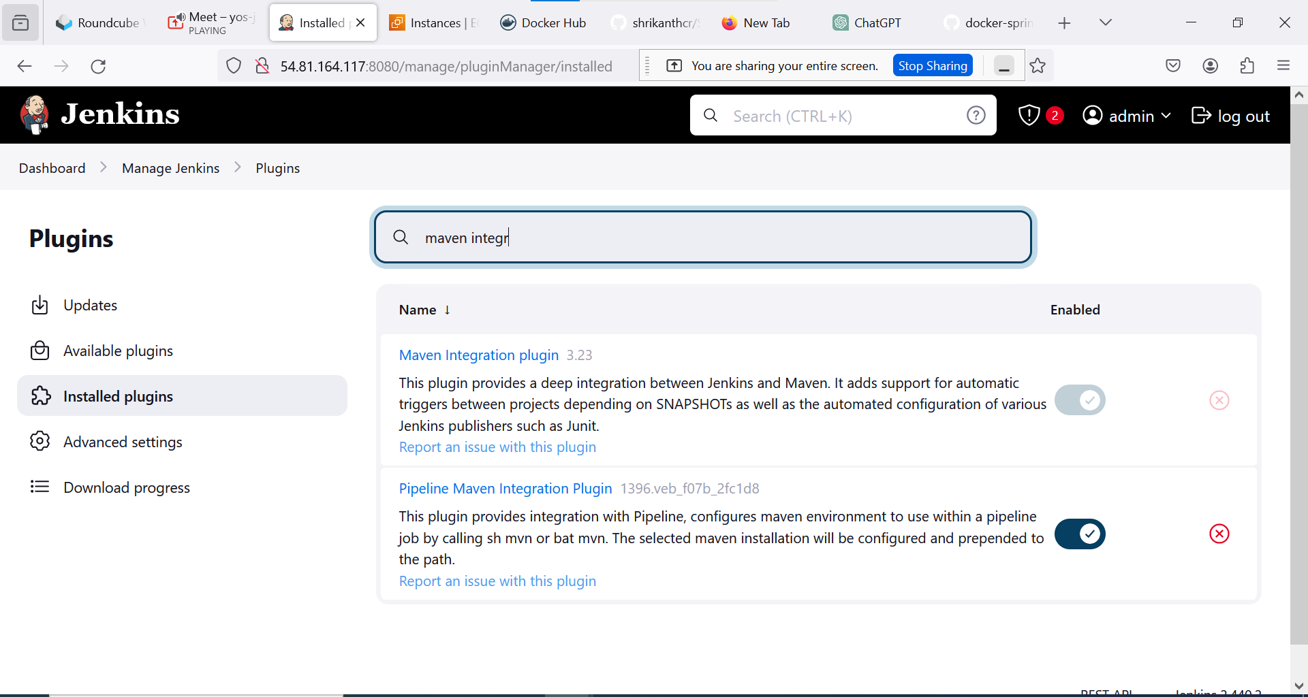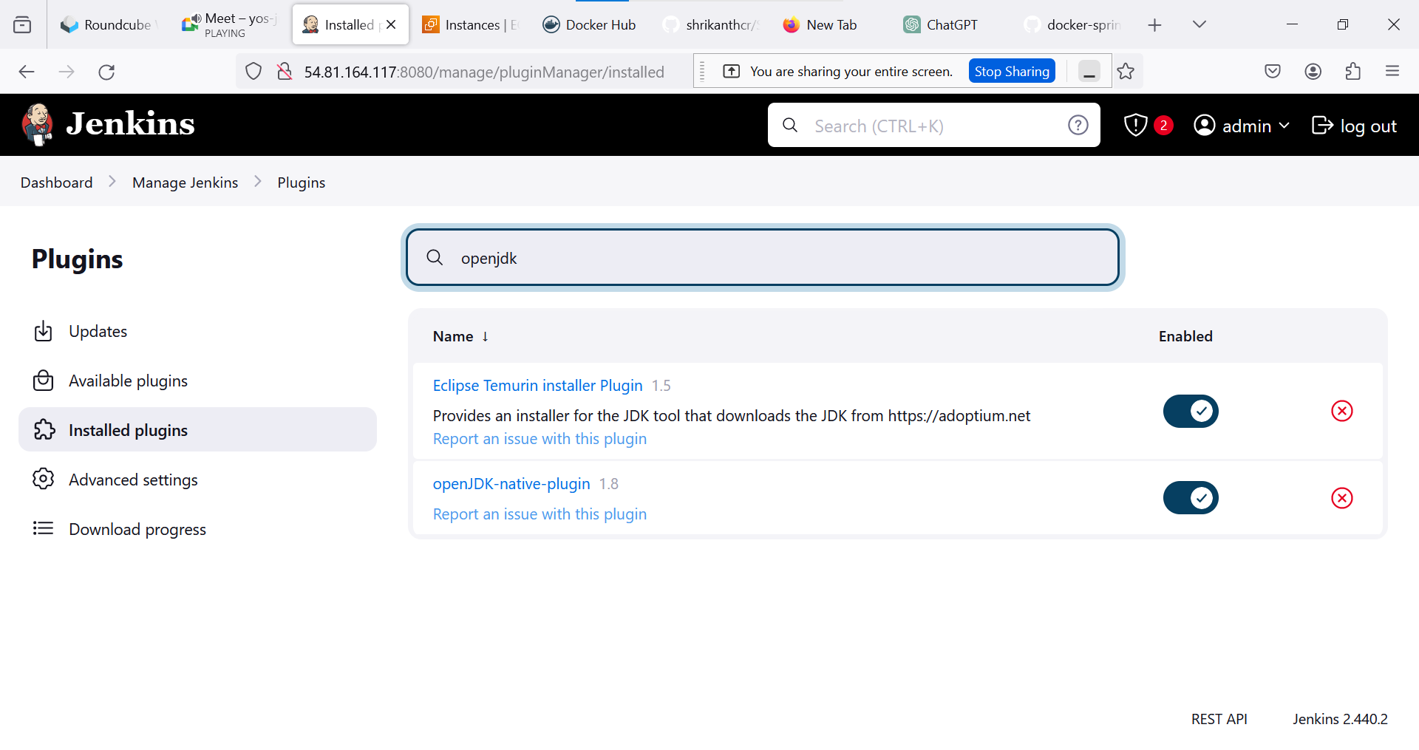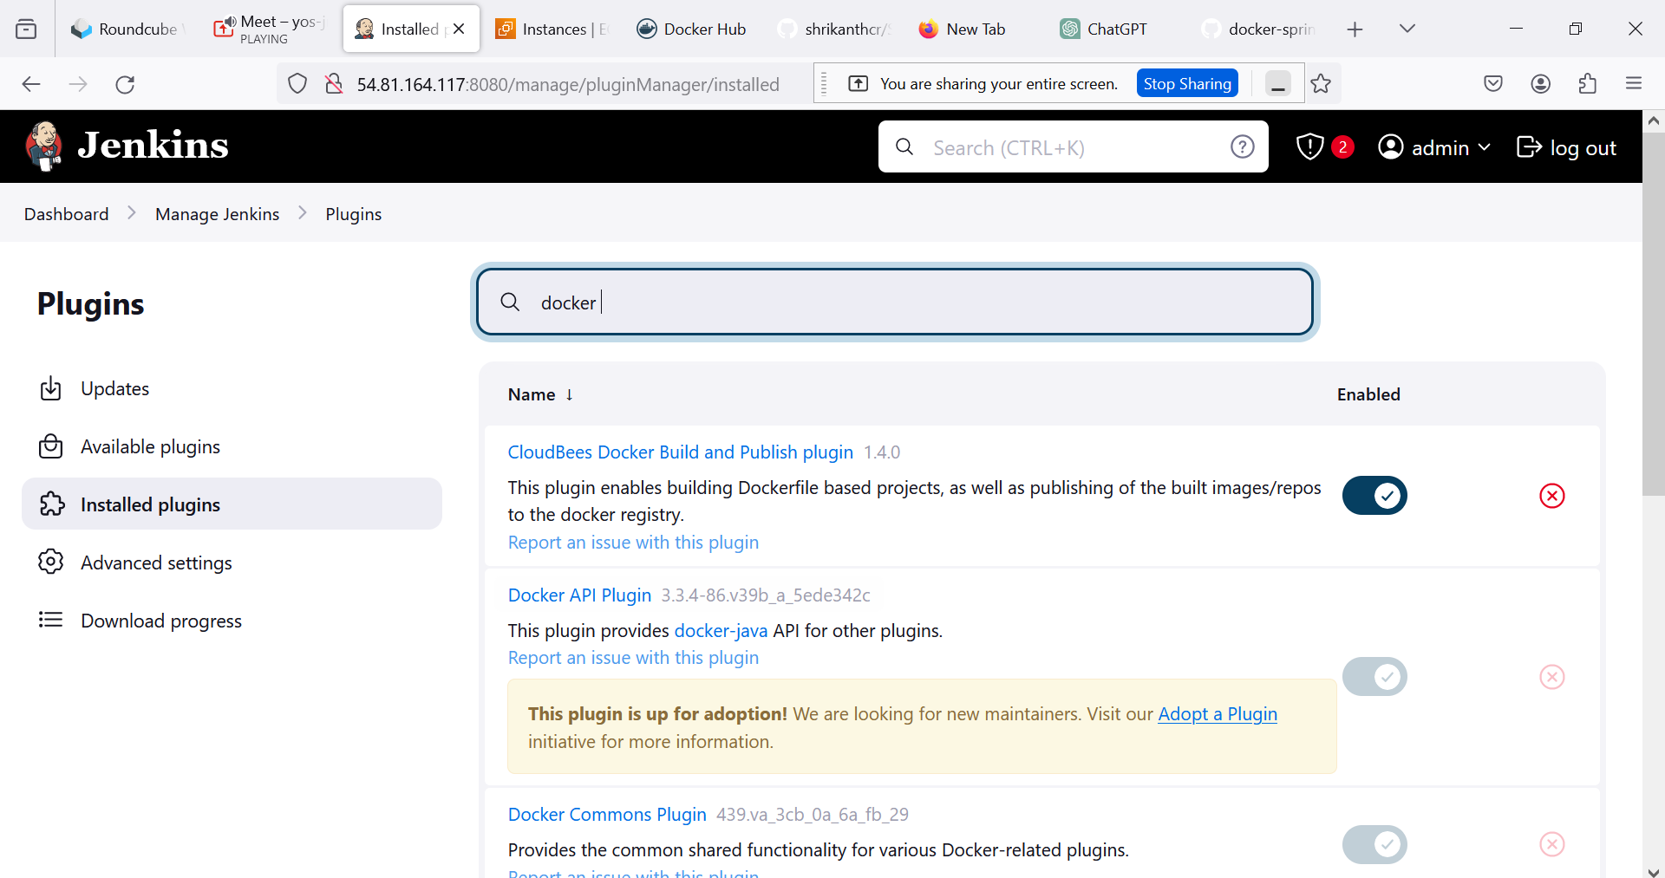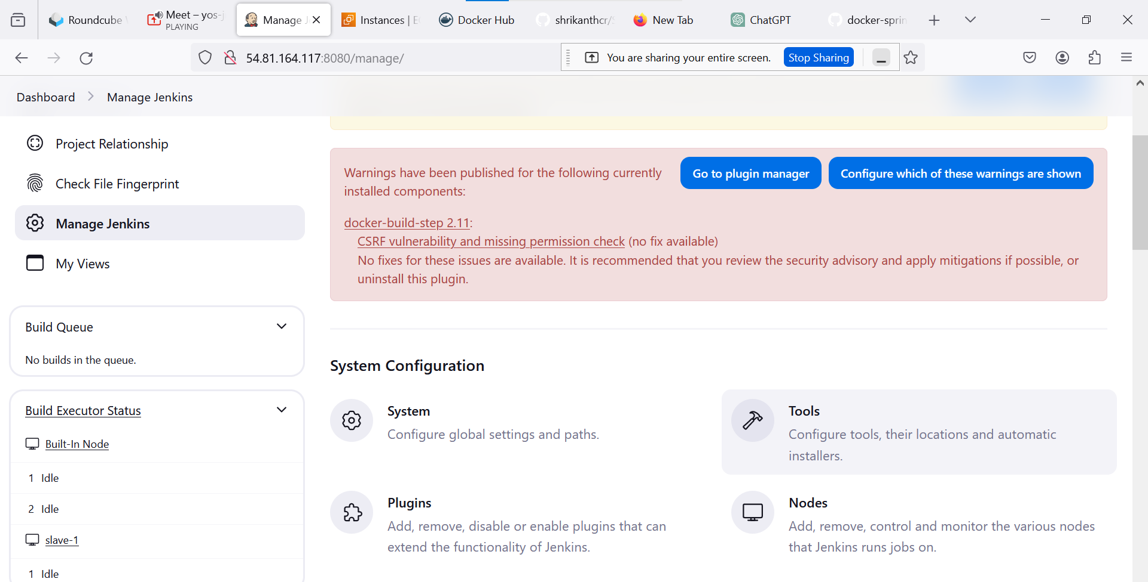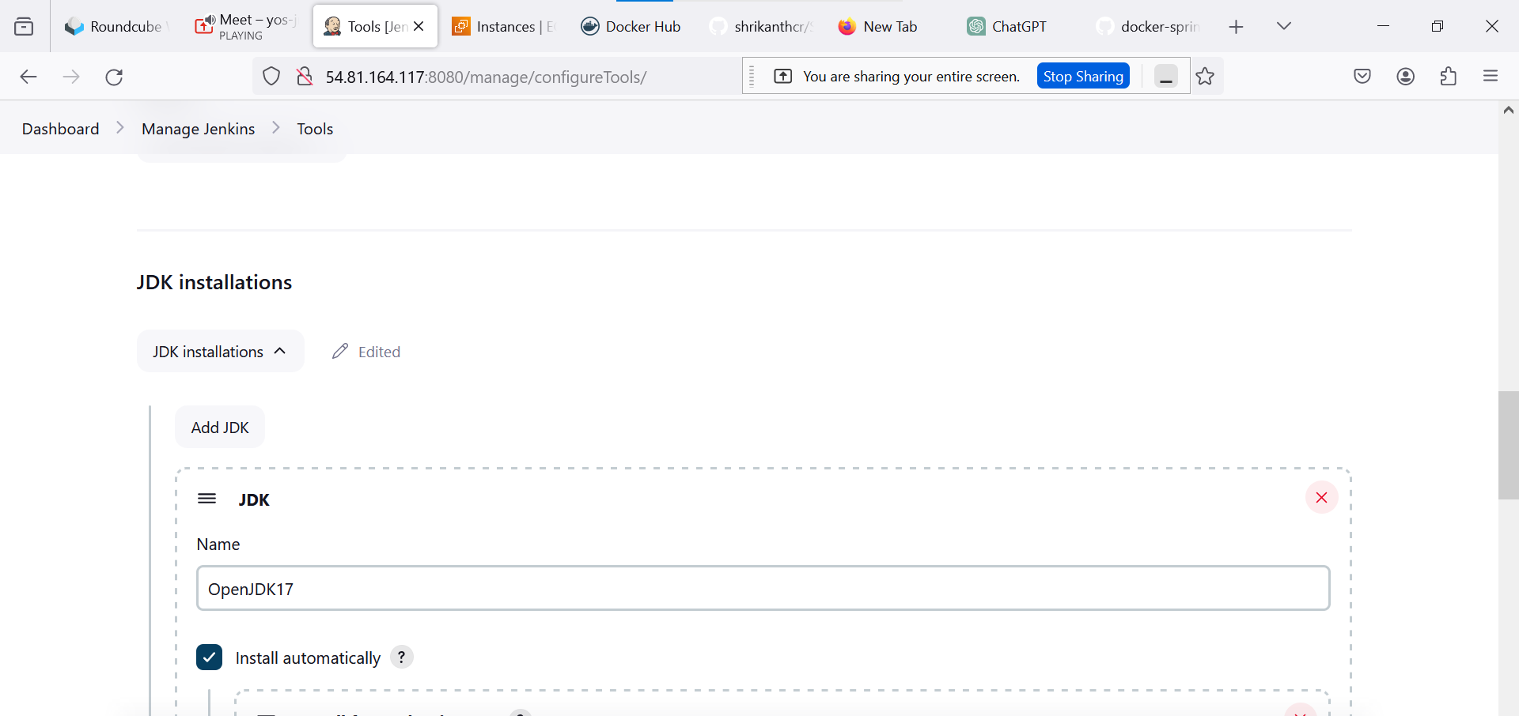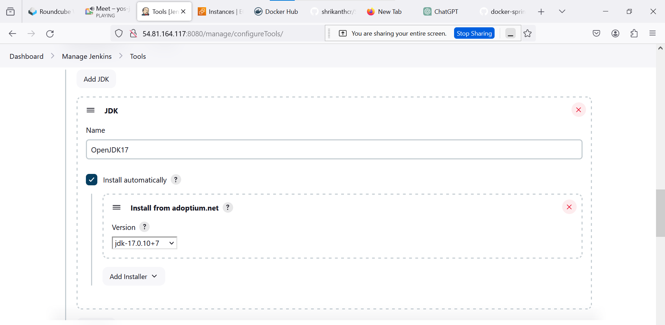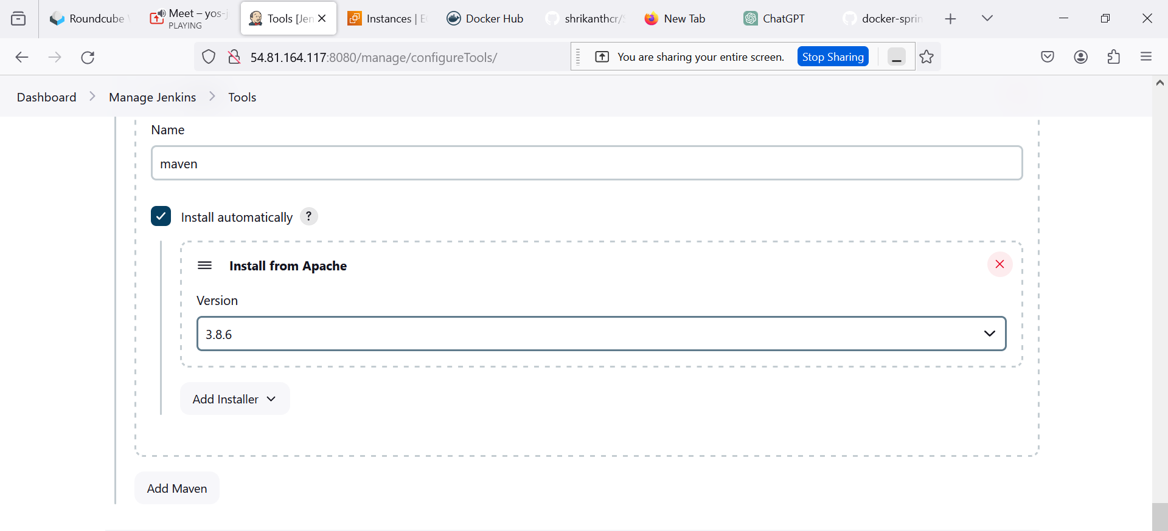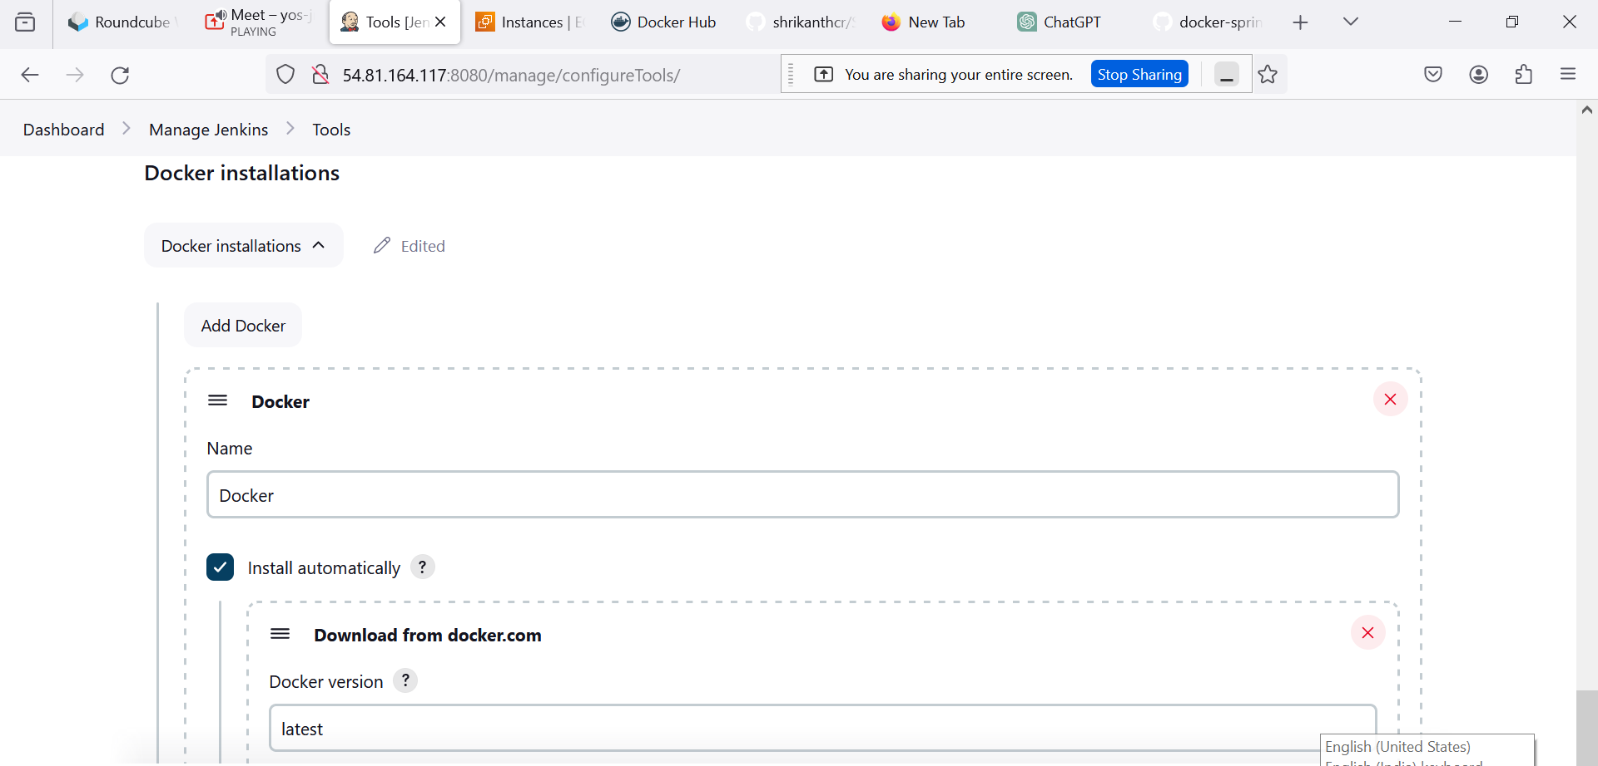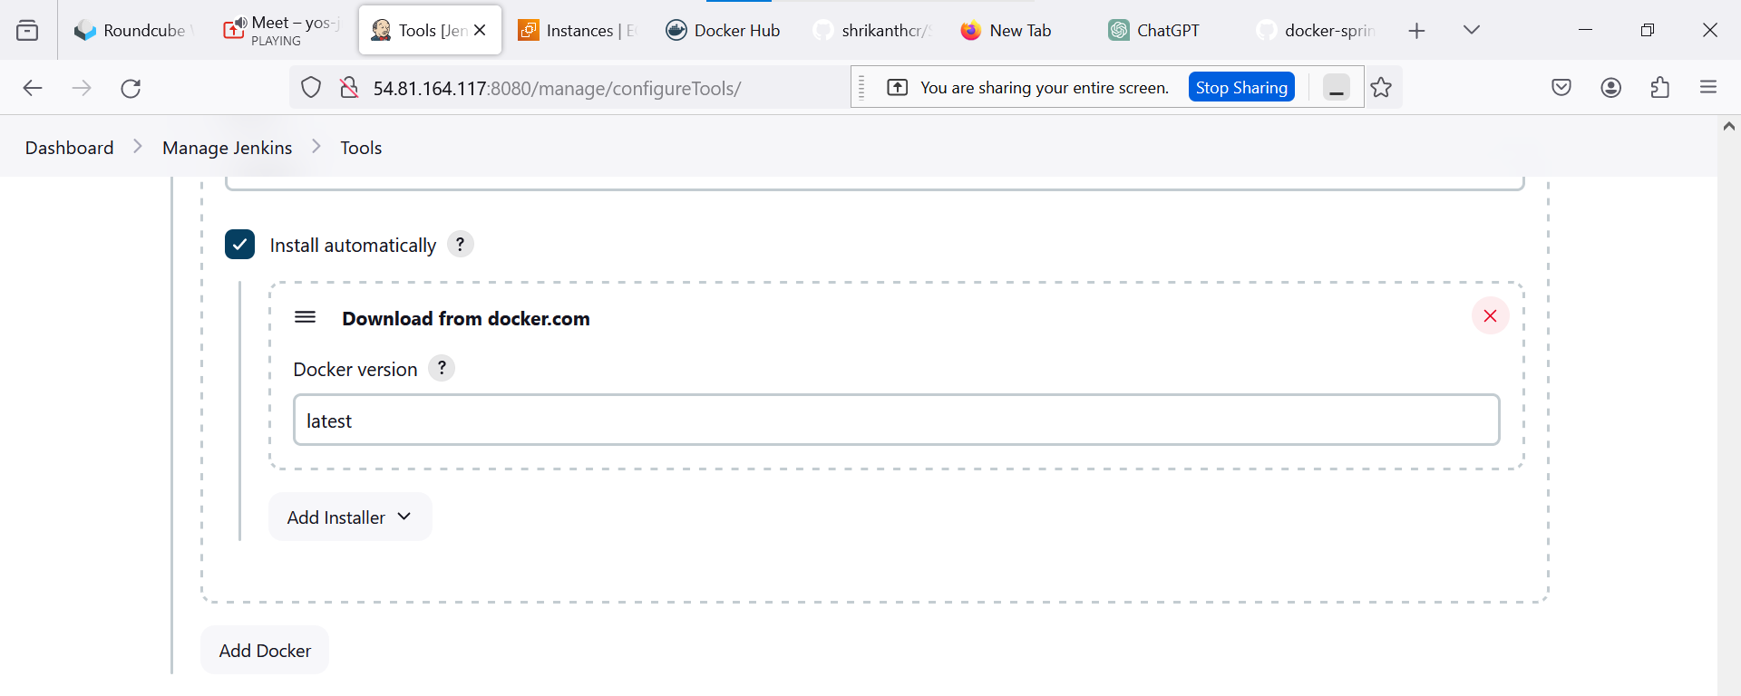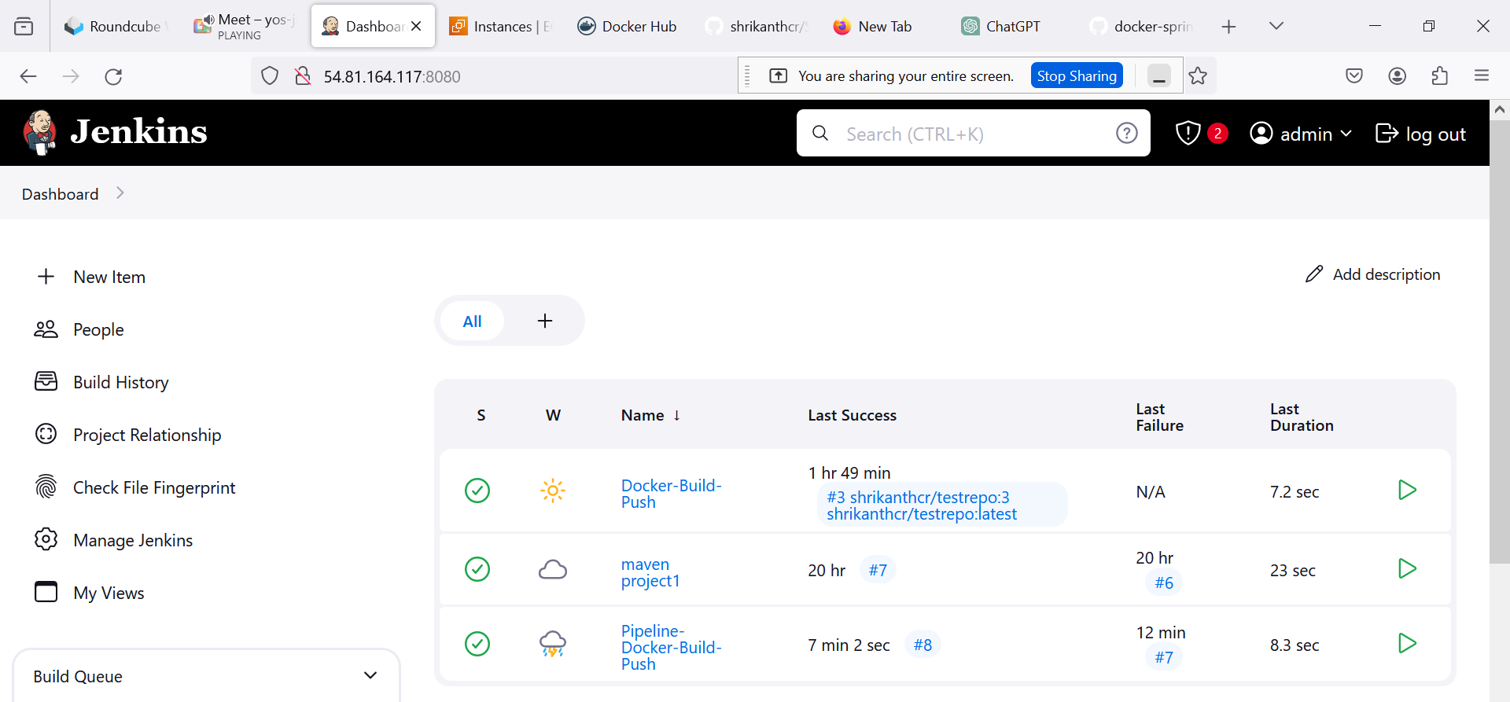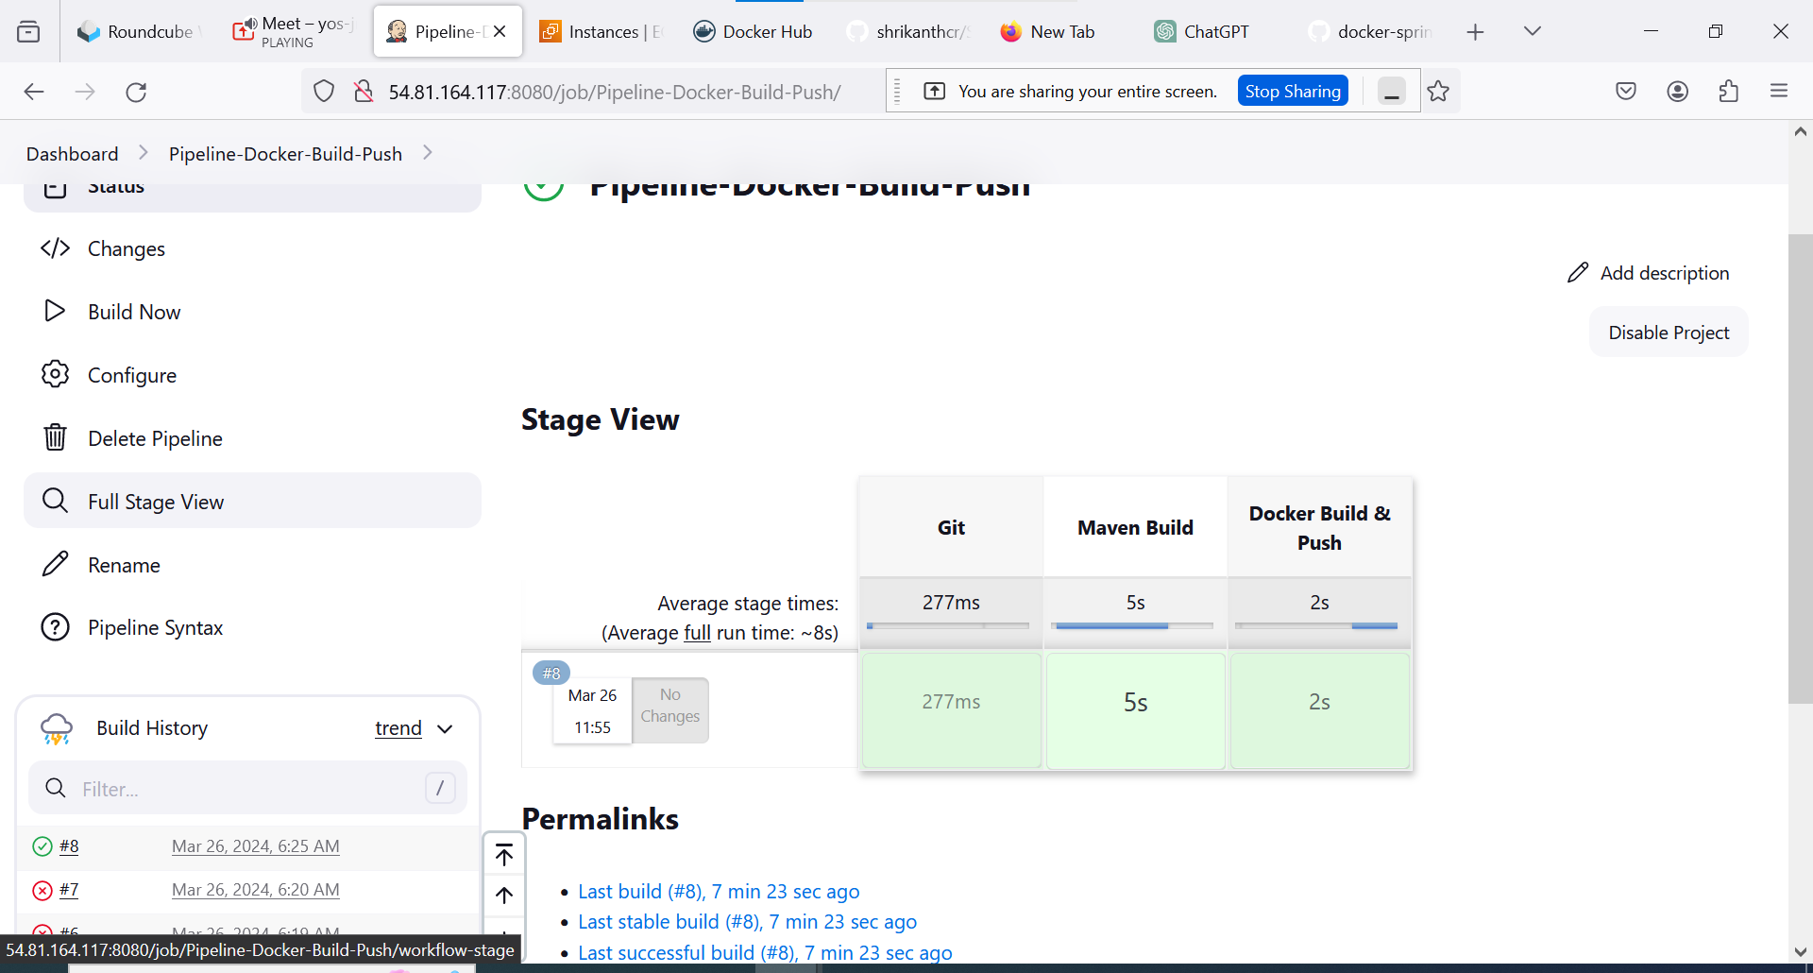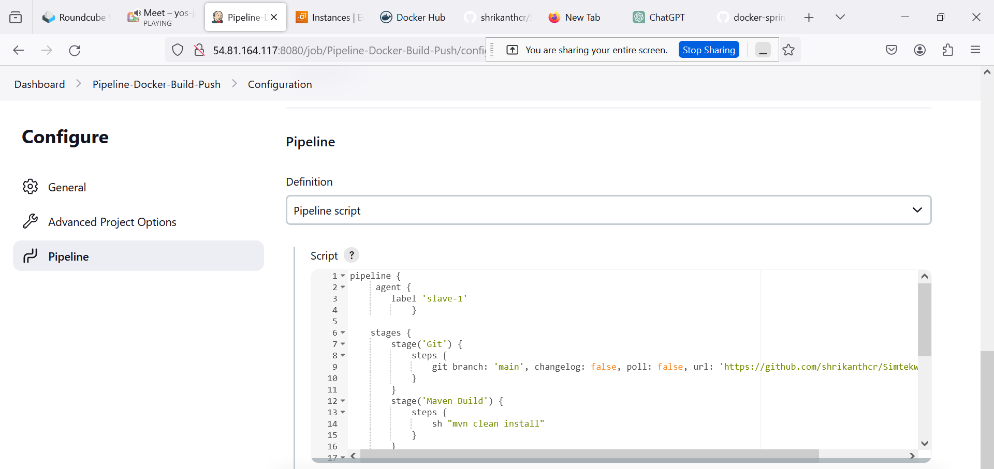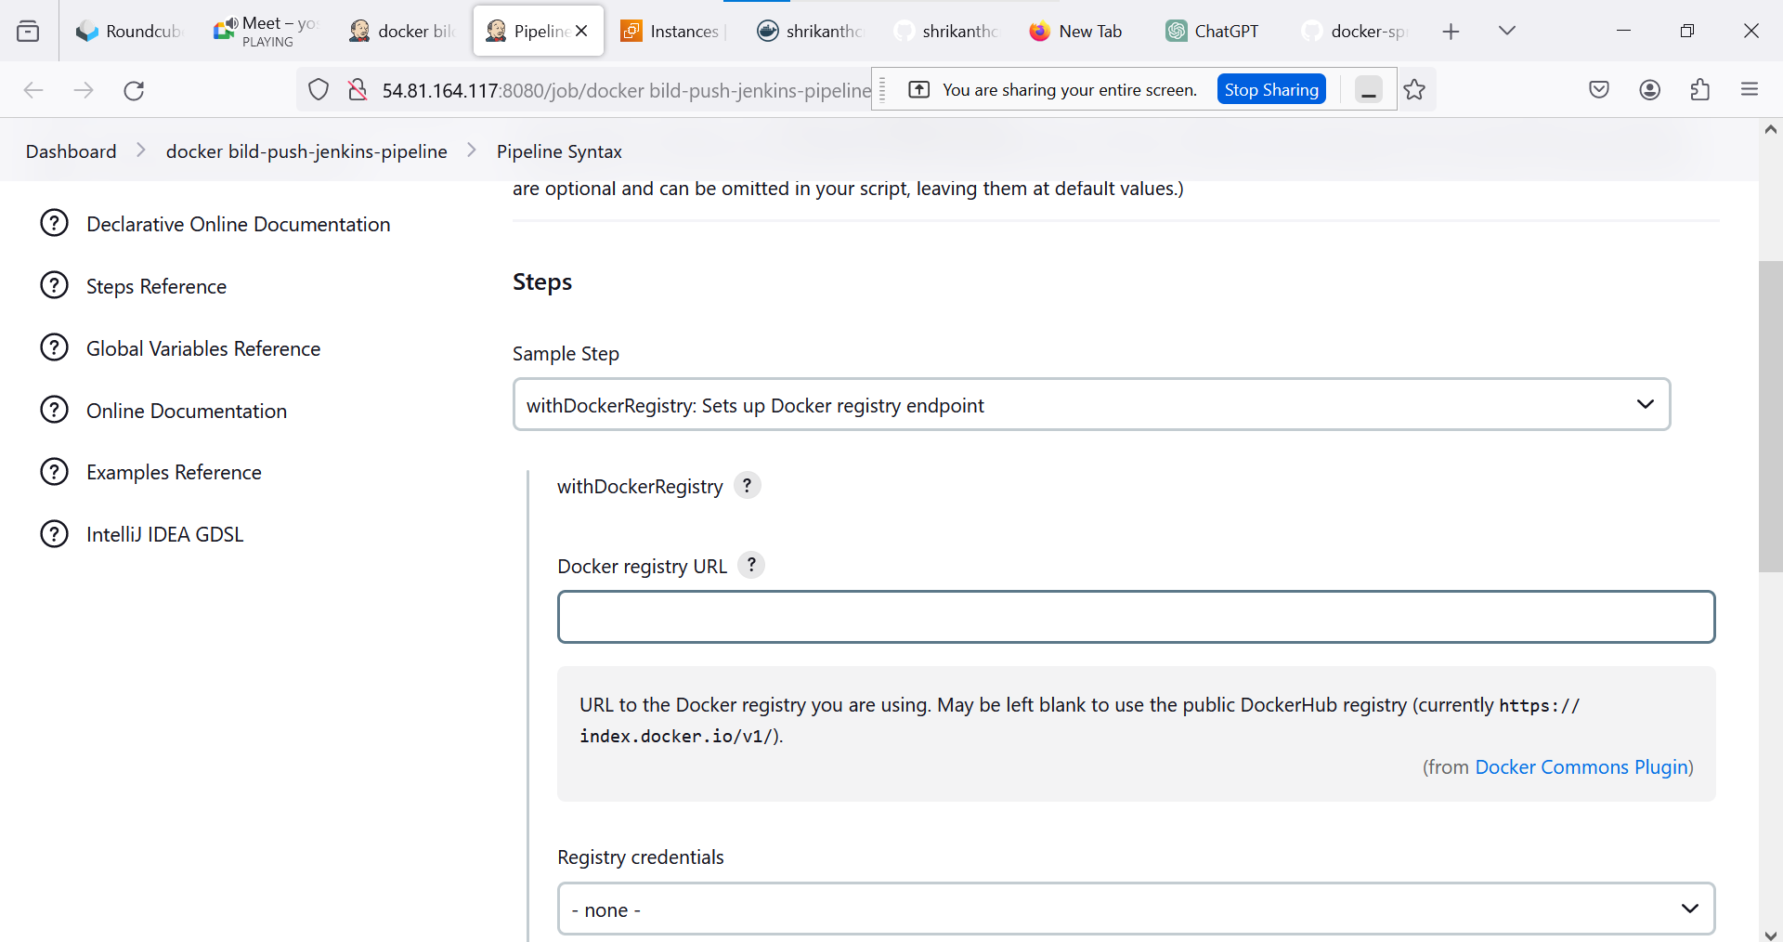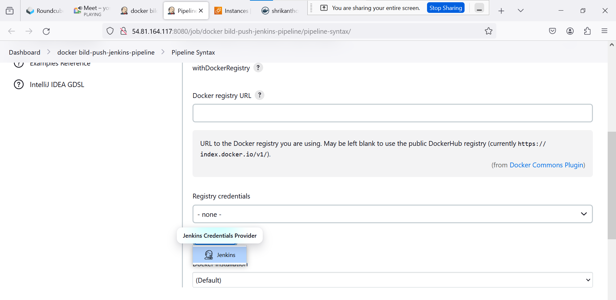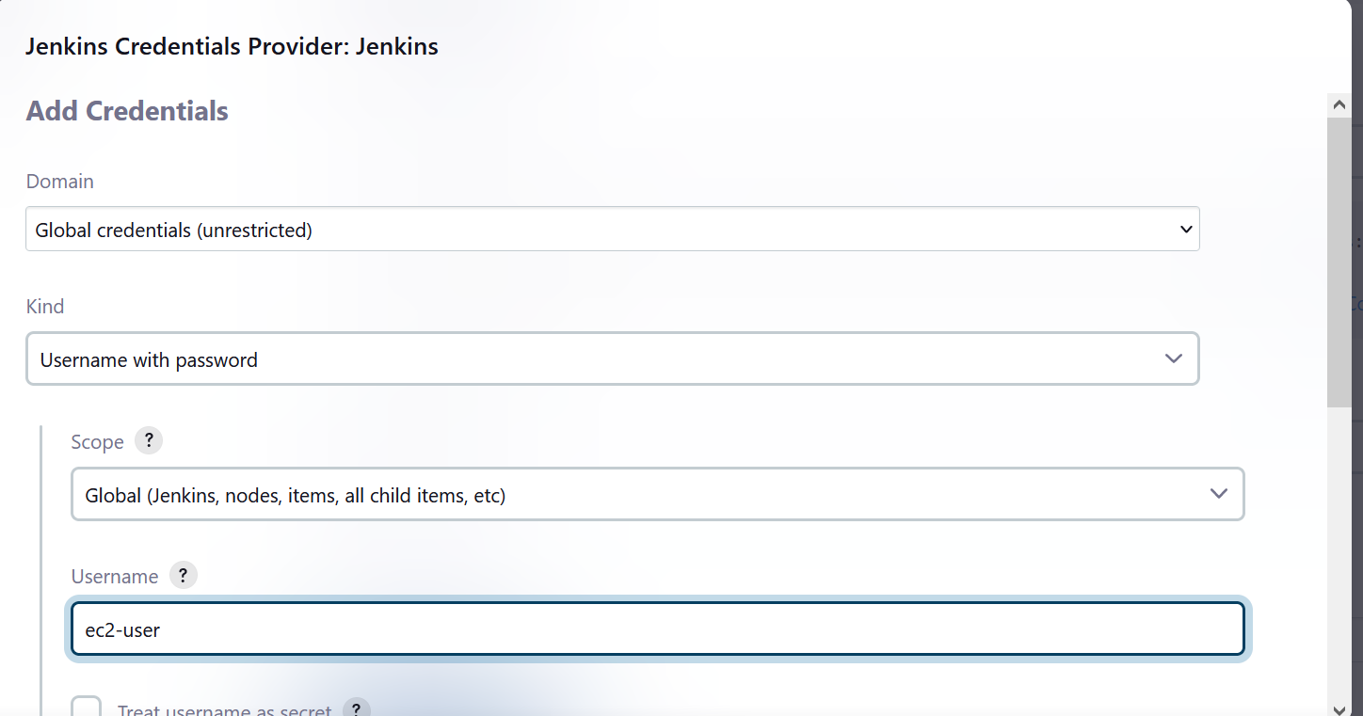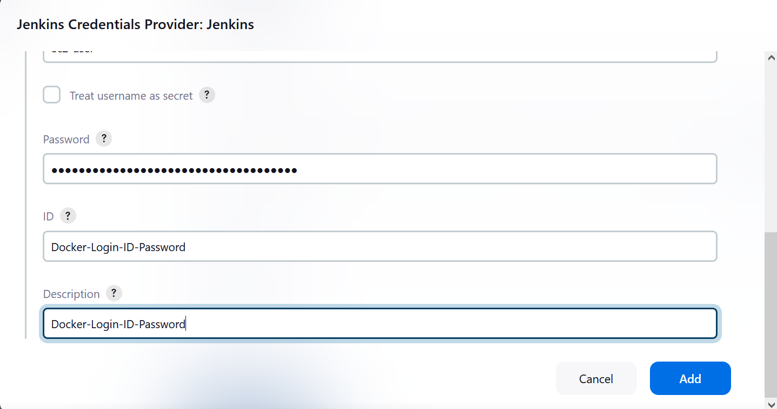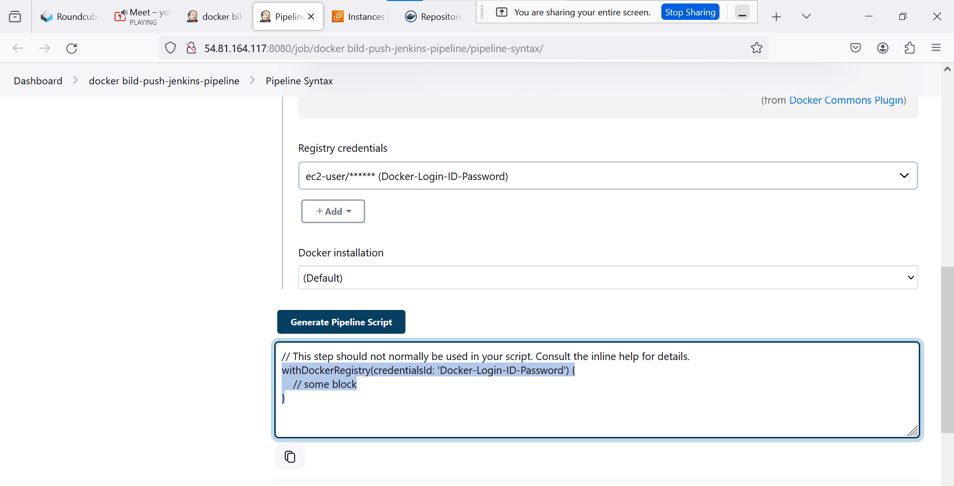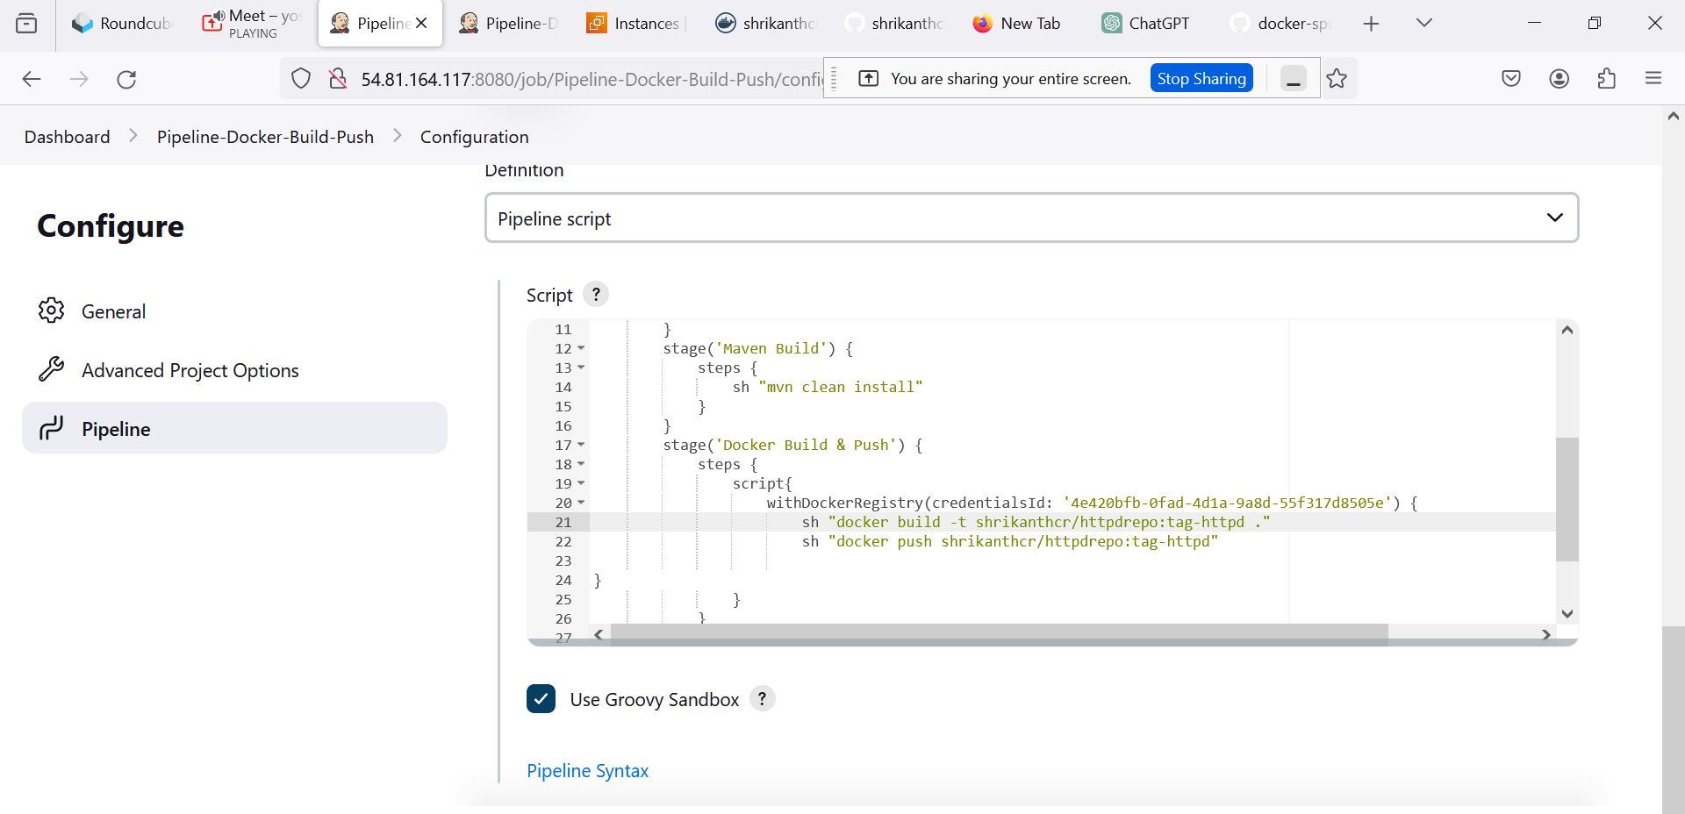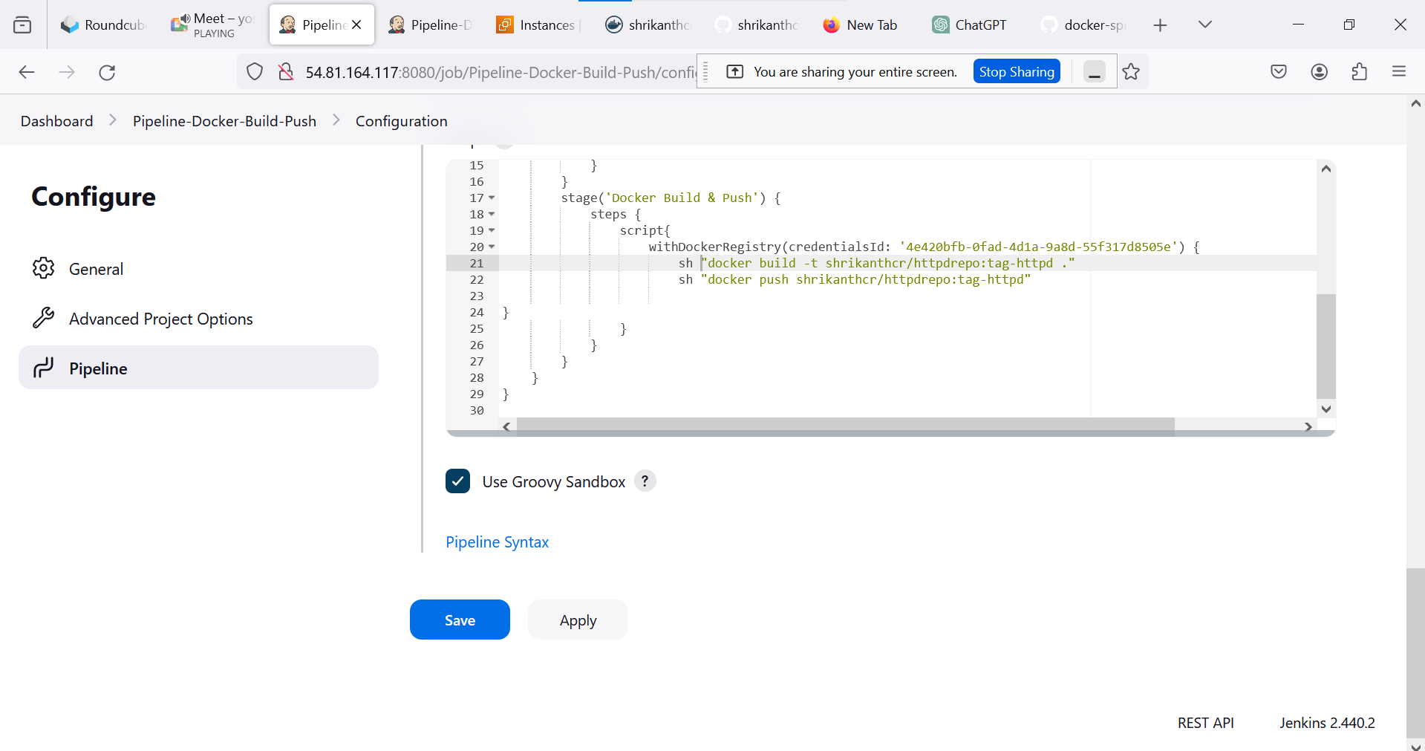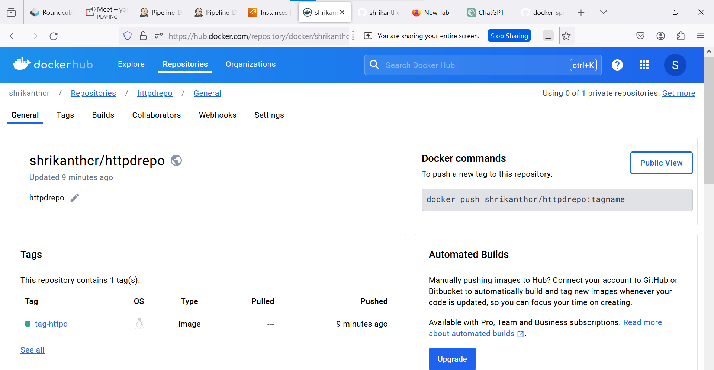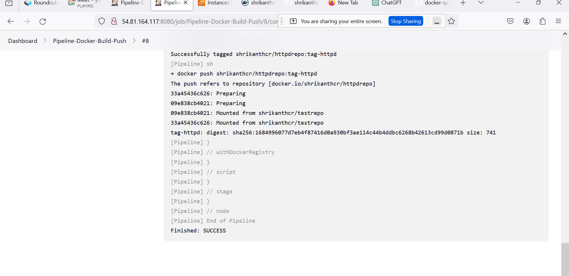

pipeline {

agent {

label 'slave-1'

}

stages {

stage('Git') {

steps {

git branch: 'main', changelog: false, poll: false, url: 'https://github.com/shrikanthcr/Simtekway-Projects.git'

}

}

stage('Maven Build') {

steps {

sh "mvn clean install"

}

}

stage('Docker Build & Push') {

steps {

script{

withDockerRegistry(credentialsId: '4e420bfb-0fad-4d1a-9a8d-55f317d8505e') {

sh "docker build -t shrikanthcr/httpdrepo:tag-httpd ."

sh "docker push shrikanthcr/httpdrepo:tag-httpd"

}

}

}

}

}

}